A guide to AI and ML
Generative AI tools can create new and original content, from text and images to music and code. But how do these tools produce such creative and relevant results? The answer lies in the relationship between artificial intelligence (AI) and machine learning (ML).
Understanding how AI and ML work together is a valuable professional skill. It can help you navigate new technologies as they transform the workplace, enabling you to contribute to AI-driven projects or even lead your own AI initiatives.
alt=""

Generative AI and machine learning
Artificial intelligence is a broad field focused on creating tools that can complete tasks typically associated with human intelligence. Generative AI is a type of AI, and it is powered by machine learning (ML), a specific technique that enables a tool to learn from data without being explicitly programmed for every possible scenario. While both terms seem similar, ML is a subset of AI used by many of the tools available today.
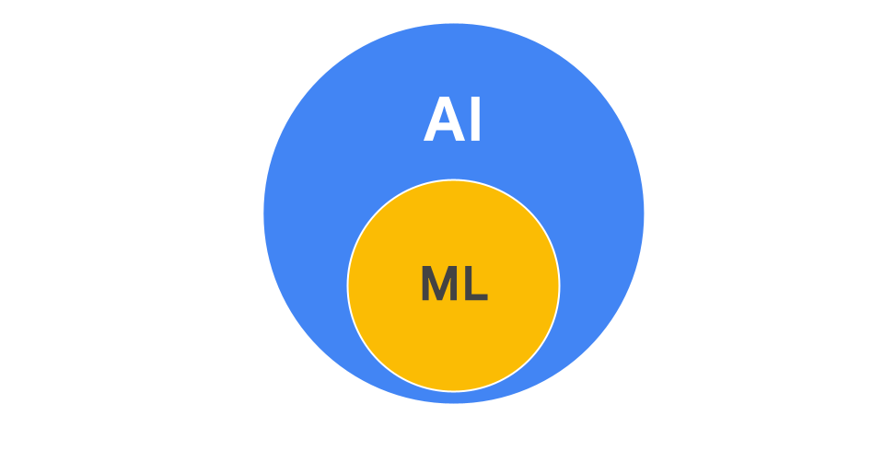

Approaches to machine learning
There are three common ML approaches used to develop AI tools:
- Supervised learning is used to train tools from a massive dataset that has been labeled by humans. This technique is often used when there is a specific, known output in mind. For example, an image generator is trained on millions of labeled pictures, like ones explicitly labeled "cat." ML enables the tool to recognize the features, patterns, and characteristics of cats so that it can create custom, new images.
- Unsupervised learning is used to train tools from a dataset that has not been labeled by humans. This technique is used to identify patterns and structures in data when there isn't a specific, known output in mind. For example, an image generator analyzes a large dataset of animal photos. ML enables the tool to identify patterns on its own, clustering images with similar features like whiskers and pointy ears. This allows it to learn what a "cat" looks like without any human-provided labels.
- Reinforcement learning is used to train tools through a process of trial-and-error that is guided by feedback. This technique is used to continuously refine and improve a tool's performance on a specific task. For example, after an image generator creates a picture of a cat, it receives feedback from a human evaluator. If the feedback is positive, this signals that the output was successful. This feedback is collected and used by developers to help improve future versions of the AI tool.
Many of today's AI tools use a combination of all three ML approaches to create text, images, video, and more.
However, it's important to note that the "learning" described in these approaches only happens during the tool's development and training—before it's released to the public. The feedback and data collected from users helps developers improve future versions of the tool, but the AI is not actively learning in real-time as you use it. You'll learn more about the specifics of the AI training process later.

Rule-based AI: A different approach
While many modern AI tools are powered by machine learning, another common approach is rule-based AI. These tools operate using a set of hard-coded rules created by human developers and do not learn from new data. They follow their specific instructions precisely.
For example, a simple customer service chatbot might be programmed with the rule: "If a user's message contains the phrase 'tracking number,' respond with a link to our package tracking website." The chatbot will follow this rule every time, but it cannot adapt or understand any requests that fall outside of its pre-written rules.
You may encounter rule-based AI in workplace tools that are designed for predictable tasks. This approach is less flexible than machine learning, which allows AI tools to adapt and handle a wider range of complex, real-world data.

Resources for more information
If you'd like to learn more, check out PAIR Explorables, a collection of interactive articles that can help you explore different AI concepts and experience how they work.

